TEACHER:  Elma Katica | DATE:  March | TIME: | SCHOOL: ‘Hamdija Kresevljakovic’ primary school | CLASS: Ia,b
Class profile: | Ia – 14 students  Ib – 13 students, special needs – one student
Topic: | MY BODY
Type of lesson: | PPP (Presentation, Practice, Production)
Learning outcomes: | A1.1. Tumači slušani sadržaj koristeći strategije slušanja  A2.1. Koristi vokabular, jezičke strukture i zakonitosti analizirajući specifičnosti izgovora slušanog sadržaja.  C1.1. Učestvuje u različitim oblicima govorne produkcije koristeći obilježja (ne)standardnog jezika.  C2.1. Koristi različite komunikacijske strategije u govoru na engleskom jeziku.
Indicators: | A1.1.1. Prepoznaje kratke riječi pri slušanju uz vizuelni poticaj reagujući neverbalno.  A2.1.1. Prepoznaje ključni vokabular slušanog sadržaja uz vizuelni i/ili multimedijalni poticaj.  A2.1.2. Povezuje riječi sa vizuelnim i/ili multimedijalnim prikazima na osnovu slušanog sadržaja uz često horsko ponavljanje.  C1.1.1. Ponavlja kratke polako izgovorene riječi odgovarajućom intonacijom.  C1.1.2. Izgovara kratke i učestale riječi na osnovu audio, vizuelnog ili multimedijalnog sadržaja uz poticaj nastavnika.  C1.1.3. Odgovara kratko na jasno postavljena pitanja zatvorenog tipa (Yes./No.); Is it a head?(Yes./No.); How many hands?
Correlation: | P.E. (body movements), My environment, Music, Math, Art (colouring)
Evaluation: | Students recognize and name body parts.
Sources/ literature: | New English Adventure Starter A
DESCRIPTION OF ACTIVITIES/ CLASS MANAGEMENT
Students are greeted by their teacher. 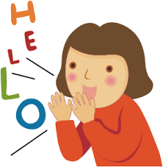

ACTIVITY 1
Listen and say.
Students look at the drawing of a boy on the board. They name the body parts in their L1. They add information about the number as well (dvije ruke, dvije noge, jedna glava…).
Then they listen to (English Adventure Starter A Track 1.10) and repeat the words: head, hands, body, feet. Teacher has prepared key words as stickers and asks a volunteer to come to the board and label the body parts he/she hears.

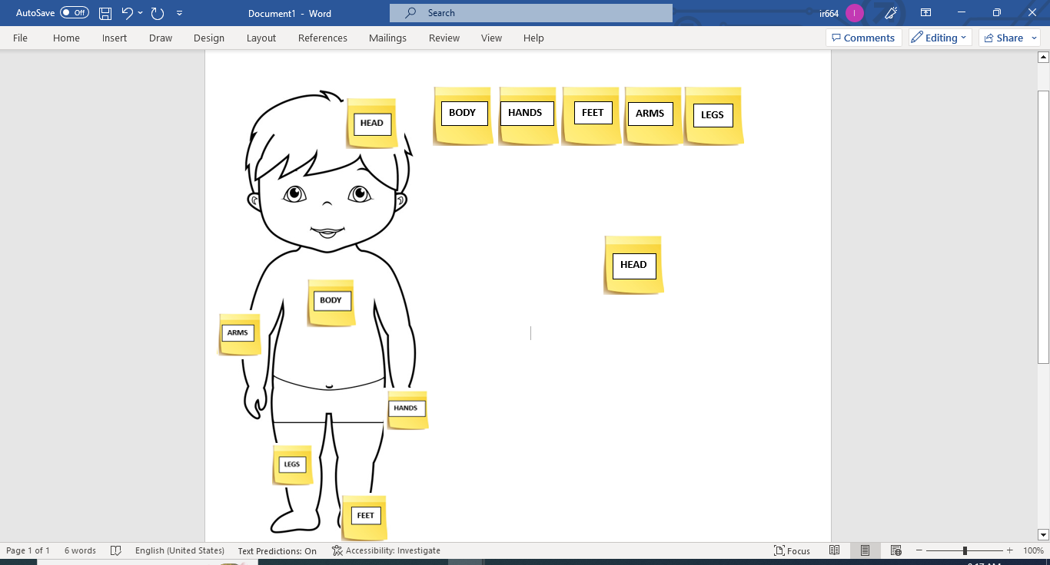
Students stand up and copy the teacher as she says the words and points to her own body parts (my head, my body, my feet, my hands). Students are introduced to two additional words for body parts: my arms and my legs.
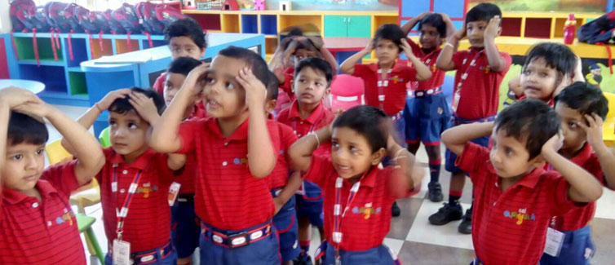

ACTIVITY 2
Listen and find.
Students look at the flashcards showing the mentioned body parts and repeat the words first chorally and individually.
They do the following activity in pairs. The flashcards are stuck to the board by magnets. In each pair one student says the words while the other needs to move the flashcards so that they are put in the correct order.

ACTIVITY 3
Listen and draw.
Students look at the green monster in their books English Adventure Starter A p. 9, ex.11. They are asked to describe the monster the way it looks at the beginning (one head, one body, three hands and three arms, one leg and one foot.) After that they listen to the recording (English Adventure Starter A Track 1.21), and they need to draw the missing body parts. When they finish they are asked to show their drawings to their friends.

.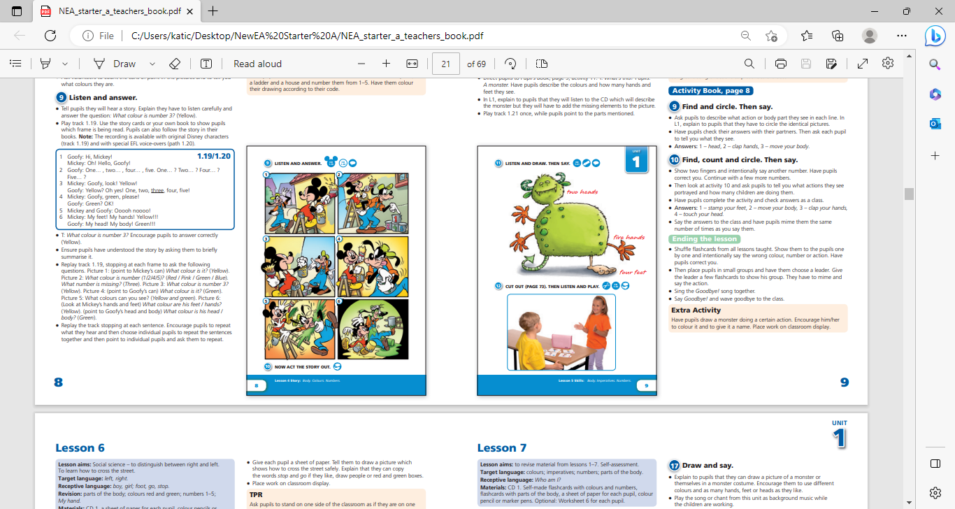

ACTIVITY 4
Cut and glue.
In the following activity students need to cut the body parts and glue them in their notebooks correctly. 